# **Task-7**

**Date –** 16th July 2024

**Members of team:** Nichenametla Yadhu Vamsi, Rashmi Singh, Chandan Kumar, Vishesh Chhaperwal, Kush Thakur, Ranga Sudharani, Khushi Prajapati

**ECG SoC in Real-Time Cardiac Monitoring Systems**

## Introduction:

An **ECG SoC (Electrocardiogram System on Chip)** is a specialized integrated circuit designed to handle the acquisition, processing, and analysis of electrocardiogram (ECG) signals in real-time or near-real-time applications. These chips are crucial in medical devices that monitor and diagnose heart conditions, providing healthcare professionals with valuable insights into a patient's cardiac health.

## ECG SoC Architecture:

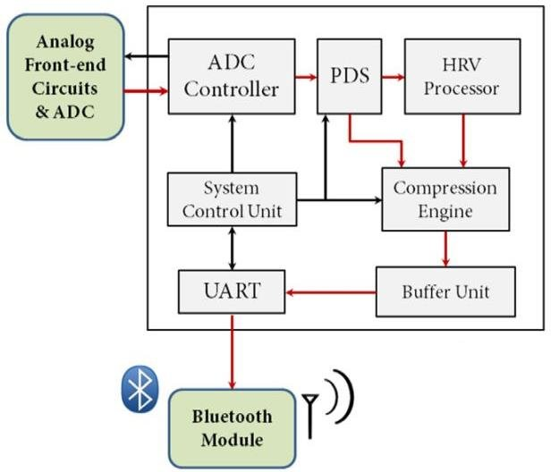

Figure:1. Block diagram of ECG SoC

The working of an ECG SoC (Electrocardiogram System on Chip) involves several stages and components working together seamlessly to acquire, process, and analyse ECG signals.

## Components/ICs of ECG SoC:

### 1. Analog Front-End (AFE) IC

* **Function**: The AFE IC is responsible for interfacing with the electrodes that capture the ECG signals from the patient. It performs the initial amplification, filtering, and conditioning of the weak electrical signals to prepare them for digitization.
* **Features**:
  + **Instrumentation Amplifiers**: Amplify the tiny ECG signals while rejecting common-mode noise.
  + **Low-Pass Filters**: Remove unwanted high-frequency noise and interference.
  + **DC Offset Correction**: Adjusts the baseline of the ECG signal to eliminate baseline drift.
  + **Programmable Gain**: Adjusts the gain of the signal to accommodate different patient conditions and electrode placements.

### 2. Analog-to-Digital Converter (ADC) IC

* **Function**: Converts the analog ECG signal output from the AFE IC into a digital format that can be processed by digital signal processing (DSP) algorithms.
* **Features**:
  + **Resolution**: Determines the accuracy of the digitized signal, typically ranging from 12 to 24 bits.
  + **Sampling Rate**: Defines how frequently the analog signal is sampled and converted into digital data, crucial for capturing fast-changing signal details.
  + **Power Consumption**: Optimized for low power to extend battery life in portable ECG devices.
  + **Interface Compatibility**: Interfaces with the DSP core of the ECG SoC for seamless data transfer.

### 3. Digital Signal Processor (DSP) Core IC

* **Function**: Performs real-time signal processing tasks on the digitized ECG data, including analysis, feature extraction, and event detection.
* **Features**:
  + **Floating-point Processing**: Supports complex algorithms for ECG waveform analysis, such as QRS detection, ST-segment monitoring, and arrhythmia classification.
  + **Power Efficiency**: Executes algorithms efficiently to minimize energy consumption, crucial for battery-powered devices.
  + **Integration**: Often includes hardware accelerators for specific ECG processing tasks to enhance performance and reduce latency.

### 4. Microcontroller Unit (MCU) IC

* **Function**: Manages overall system operation, including data handling, communication with external devices, and user interface management.
* **Features**:
  + **Clock Speed**: Determines how fast the MCU can process instructions and manage real-time tasks.
  + **Memory**: Includes both volatile (RAM) and non-volatile (Flash) memory for storing program code, configuration settings, and temporary data.
  + **Peripheral Interfaces**: Interfaces with external components such as display modules, communication modules (Bluetooth, Wi-Fi), and storage devices.
  + **Power Management**: Controls power distribution and consumption across different components of the ECG SoC to optimize energy efficiency.

### 5. Communication Interface IC (e.g., Bluetooth/Wi-Fi)

* **Function**: Facilitates wireless transmission of processed ECG data to external devices, such as smartphones, tablets, or centralized monitoring stations.
* **Features**:
  + **Protocol Support**: Implements standard communication protocols (e.g., Bluetooth Low Energy, Wi-Fi) for interoperability with different devices.
  + **Data Rate**: Determines the speed at which data can be transmitted, ensuring real-time monitoring capabilities.
  + **Security**: Implements encryption and authentication mechanisms to protect sensitive ECG data during transmission.
  + **Range and Coverage**: Ensures reliable connectivity within the intended operating range for wearable or ambulatory ECG monitoring devices.

## **Key Features:**

* **Analog Front-End**: Amplifies and filters ECG signals for accurate detection.
* **Digital Signal Processing**: Extracts and analyzes ECG waveform features (e.g., P-wave, QRS complex, T-wave).
* **Communication Interfaces**: Enables real-time transmission of ECG data to monitoring systems.

## Real-Time Cardiac Monitoring Systems

**Problem Statement:** Continuous monitoring of cardiac activity is critical for early detection of arrhythmias, heart conditions, and patient health management. Traditional ECG systems are bulky, require multiple components, and may lack real-time data transmission capabilities.

**Solution Using ECG SoC:** Implementing ECG SoCs in cardiac monitoring systems addresses these challenges by providing compact, integrated solutions with high-performance signal processing and wireless connectivity.

## **Advantages of Using ECG SoC:**

1. **Portability**: Compact size suitable for wearable devices and ambulatory monitoring.
2. **Real-Time Monitoring**: Provides immediate feedback on cardiac health status.
3. **Integration**: Combines multiple functions into a single chip, reducing system complexity.
4. **Data Connectivity**: Enables seamless data transfer for remote monitoring and analysis.

## **Implementation Example:**

1. **Application**: Wearable ECG monitoring device.
2. **Components**: ECG SoC with integrated ADC, DSP core, Bluetooth module.
3. **Tasks**: Continuous ECG signal acquisition, real-time analysis for arrhythmia detection, wireless transmission to mobile app.
4. **Outcome**: Enhanced patient comfort, early detection of cardiac abnormalities, improved healthcare management.

## Conclusion

ECG SoCs offer a transformative solution for real-time cardiac monitoring systems, combining advanced signal processing capabilities with wireless connectivity in a compact form factor. By leveraging ECG SoCs, healthcare providers can achieve improved patient outcomes through early detection and proactive management of cardiac conditions, ultimately enhancing patient care and quality of life.

## References

<https://ieeexplore.ieee.org/document/6418426>

H. Kim, R. F. Yazicioglu, S. Kim, N. V. H. A. Artes, M. Konijnenburg, J. Huisken, J. Penders, and C. Van Hoof, “A configurable and low-power mixed signal SoC for portable ECG monitoring applications,” in 2011 Symposium on VLSI Circuits (VLSIC), 2011, pp. 142–143

H. Liang, Z. Yanfang, and H. Lesheng, “Non-amplifying ECG signal acquisition system based on Σ-Δ A/D,” in IEEE 2011 10th Int. Conf. Electron. Meas. Instruments, 2011, pp. 105–108

<https://www.researchgate.net/publication/323079803_Heart_rate_monitoring_using_ARM_soft_core_processor_based_system-on-chip>